**Springboot Explained**

**https://github.com/shanregs/master-spboot-yt**

<https://www.youtube.com/watch?v=DQbkePm2ims&list=PL-bgVzzRdaPhNeXyQBtp8hMlUc14J2kRK&index=5>

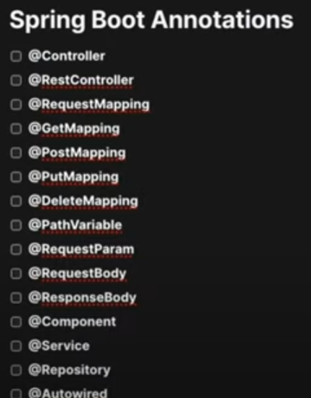

**@Controller, @ResponseBody, @RequestMapping**

@RestContoller 🡪 to indicate the output will be the data and not the html to be rendered. You don’t need to add @ResponseBody in each and every method

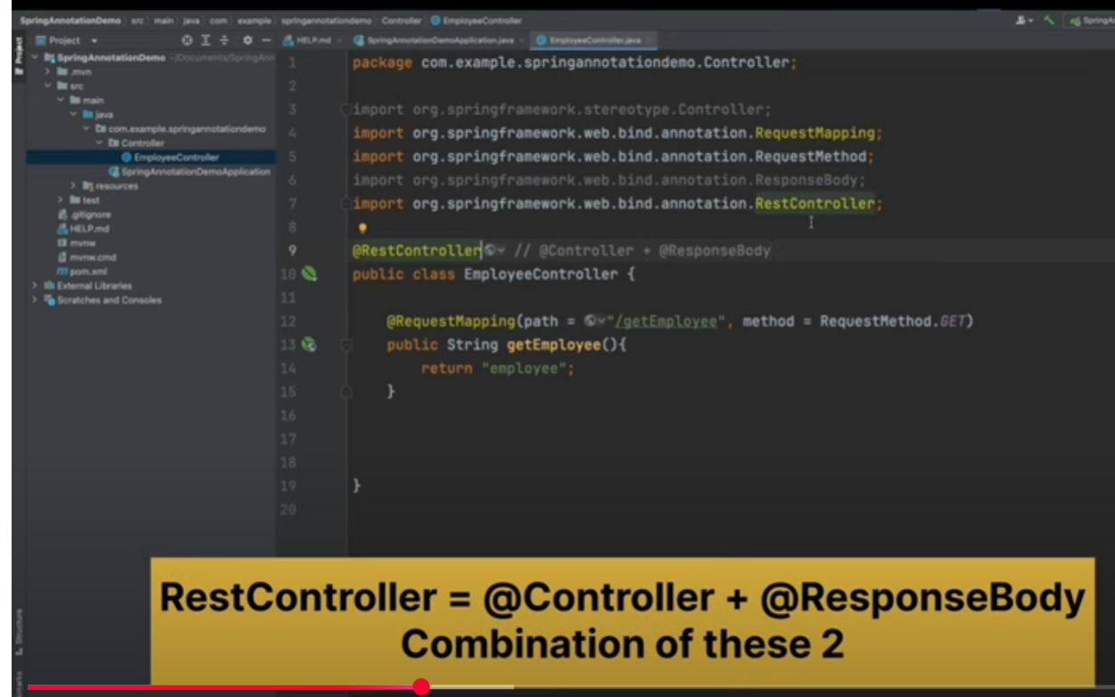

@GetMapping already includes @RequestMapping for Get

@RequestParam

@PathVariable

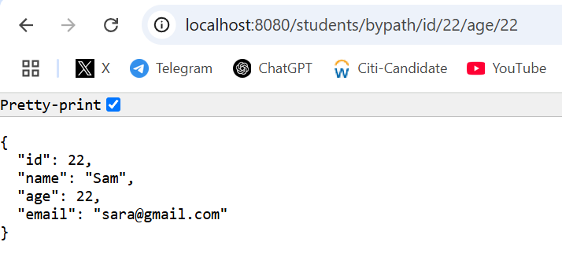

@RequestBody

**Understanding Beans and ApplicationContext in Spring Framework**

Get bean details using actuators

Get bean using Application Context . Appl Ctxt is the implementation of Spring IoC

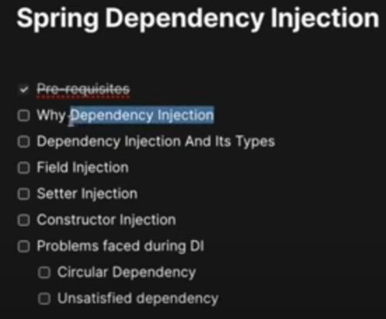

Field Injection

Setter Injection

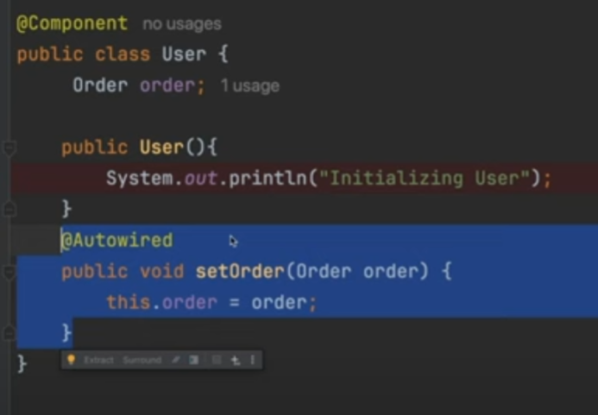

Constructor Injection

Lazy annotation to avoid circular dependency

**@ComponentScan Annotation: Deep Dive**

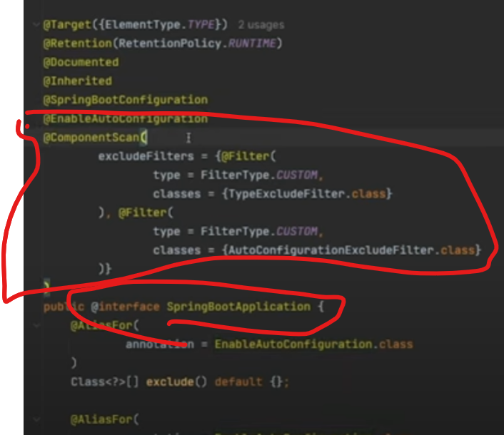

The package under **ecomAssistant** will not be scanned as the main application is under ecom package the @SpringBootApplication component scan will scan under **ecom** package

To enable the component scan, we need to add the package in component **ecomAssistant**

**Customizing Bean Nature in Spring | Bean Lifecycle, @PostConstruct & @PreDestroy**

After bean usage and before stopped on application stop– use Disposable bean interface

To stop application to see the beans destroyed

PostCOnstruct & PreDestory

